Report on Gun-4.2 run at PITZ in 2014-2015

Contents
section | subsection | section title | Author
0 | 0.1 | PITZ beamline and gun-4.2 (history) | A. Oppelt
1 | 1.1  1.2  1.3  1.4  1.5  1.6  1.7  1.8 | RF conditioning  RF feed system and conditioning procedure  Gun power  Conditioning/operation with solenoid  Vacuum activity  Typical signals of RF and interlock sensors  Long term tests statistics on unperturbed periods  Resonance temperature drift  … | Y. Renier
2 | 2.1  2.2  2.3  2.4  2.5 | Dark current  History of the dark current  Typical and final dark current measurements  Dark current momentum measurements  … | XXX
3 | 3.1  3.2  3.3  3.4  3.5 | Electron beam momentum  Maximum mean momentum vs. peak power  Phase scans and projections measured  HEDA2 vs. HEDA1 measurements  LPS tomography (with booster) | M. Krasilnikov
4 | 4.1  4.2  4.3  4.4  4.5  4.6  4.7  4.8 | E-beam transverse phase space: Emittance measurements  Various bunch charges experimentally optimized for 53MV/m (incl. simulations,  Gauss vs. flattop)  Impact of the e-beam transport  53MV/m, 500pC, history and correlation to QE  53MV/m vs. 60MV/m  60MV/m: long vs. short Gaussian  Beam brightness: measured vs. simulated  4nC measurements for THz studies (incl. transport)  Tomography update | G. Vashchenko  P. Boonpornprasert  G. Kourkafas, Y. Renier
5 | 5.1  5.2  5.3  5.4 | Cathodes  History of cathode manipulations  Cathode images  QE and QE-maps  Hot spot: “rotation experimeny” | M. Krasilnikov
6 | 6.1  6.2  6.3  6.4  6.5 | RF system  LLRF system uTCA commissioning experience  Problems with readout of gun input directional coupler (5MW 10MW coupler discrepancy, termination replacement etc.)  Problems (~kHz noise from modulator…?)  PWM implementation  … | W. Koehler  M. Hoffmann  S. Pfeiffer
7 | 7.1  7.2 | Photocathode Laser  Status overview (OSS was not available)  3D-Elli – installation, commissioning, problems, first beams | M. Groß  T.Rublack, J. Good
8 | 8.1  8.2  8.3 | RF gun stability  WCS-stabilization + readout update  uTCA measurements  Beam-based measurements  … | M. Krasilnikov  J. Schultze
9 | 9.1  9.2  9.3  9.4 | Investigations on imperfections  Photoemission studies  Beam imaging studies  Electron beam asymmetry studies (coupler kick, solenoid tilt, 2nd vacuum mirror, etc)  … | M. Krasilnikov  M. Krasilnikov  Q. Zhao  I. Isaev
10 | 10.1  10.2  10.3  10.4  10.5  10.6 | TDS  Hardware setup and main parameters/specifications  Measurement setup and procedure  Bunch profile/length measurements vs BSA and charge  LPS measurements: first tests and problems  VB measurements for THz studies (250;100;20pC)  First slice emittance measurements using TDS … | H. Huck  P. Boonpornprasert
11 | 11.1  11.2  11.3  11.4  11.5 | Plasma acceleration experiment  Intro and simulations (parameters and specs)  Setup and preparing  Commissioning (measuring)  First tests  Next steps | M. Gross
Appendix 1 |  | Beam loading at 4-5nC | M. Krasilnikov
Appendix 2 |  | Gun fast recovery tests | Y. Renier (O. Hensler)
Appendix 3 |  | E-beam optimization for high magnetic field | M. Krasilnikov
Appendix 4 |  | LPS studies (P. Lu –program) | G. Vashchenko

0. PITZ beamline and gun-4.2
A. Oppelt
The Photo Injector Test facility at DESY, Zeuthen site (PITZ), develops high brightness electron sources for modern free electron lasers like the Free-electron Laser in Hamburg, FLASH, and the European X-ray Free-Electron Laser, European XFEL. The stringent requirement …

RF conditioning

Y. Renier
The conditioning of the gun 4.2 has taken place at PITZ from …
….
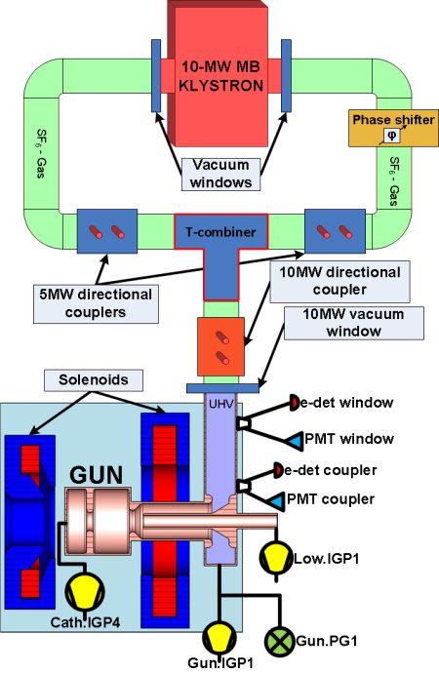
Figure 1.1.1: RF system overview

The conditioning procedure which was applied to the gun 4.2 was similar to the THALES RF window conditioning.
…

Thresholds of gun IL signals are summarized in Table 1.1.1.
Name | Threshold | Comment
PMT coupler | 1.5 V | light(lux)=0,3 x signal(V)
PMT window | 2.5 V | light(lux)=3,4 x signal(V)
e-det coupler | 1.5 V -0.6 V offset | 100kΩ -->0,8 V
e-det window | 2.0 V 0 V offset | 100kΩ -->0,8 V
Low.IGP1 | - | 1 e -6 mbar
Gun.IGP1 | 3,5 V | = 7 e-9 mbar
Gun.PG1 | 4,5 V | = 1 e-7 mbar
Cath.IGP4 | - | 1 e -6 mbar
Reflected power | 93 dBm per waveguide | 2 MW per waveguide
Table 1.1.1: Gun interlock signals with corresponding threshold

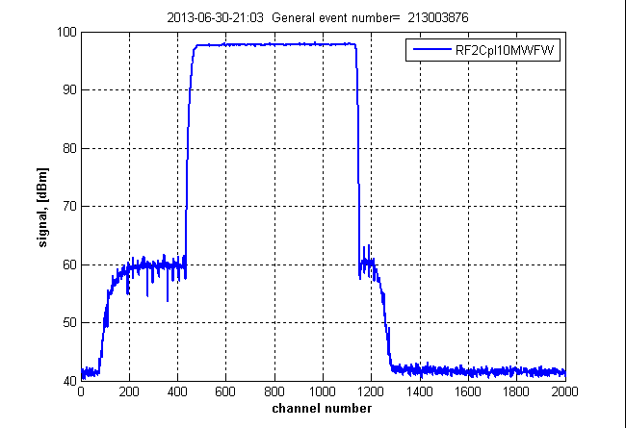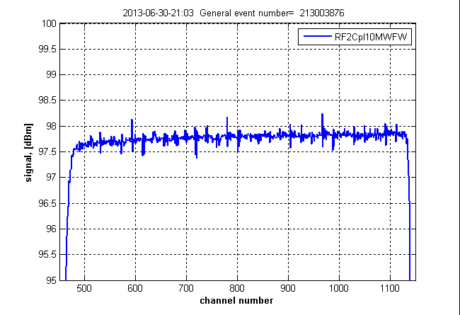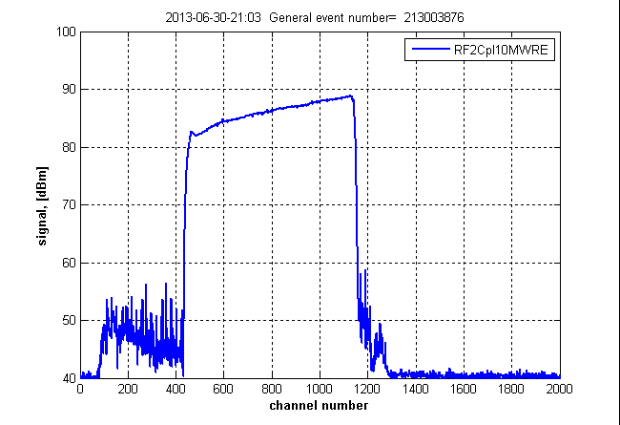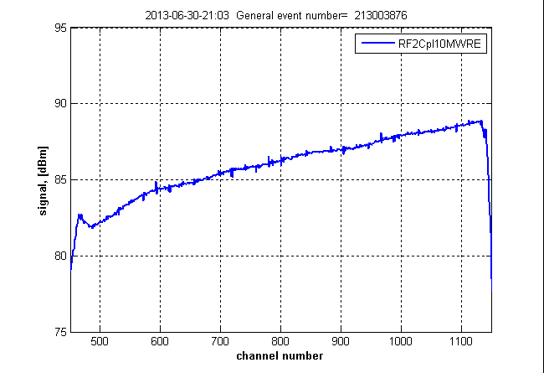
Figure 1.7.3: RF signals from 10MW directional coupler for 650 μs rf pulse length: forward power –upper row, reflected power –bottom row. A channel number in the horizontal axis corresponds to 1 μs

Conclusions
The established procedure applied to gun-4.2 …

2. Dark current
M. Krasilnikov
High electric fields at the inner surface of the RF gun can result in unwanted field emission, called dark current. The dark current was usually measured with LOW.FC1 which could be inserted in the DDC (~0.8 m downstream of the cathode). The first dark current monitor (DCM1, located at z=2.36m from the cathode) was used to monitor the evolution of the dark current.

2.1 History of the dark current

Available history of the dark current monitoring using the DCM1 is shown in Fig. 2.1.1 …
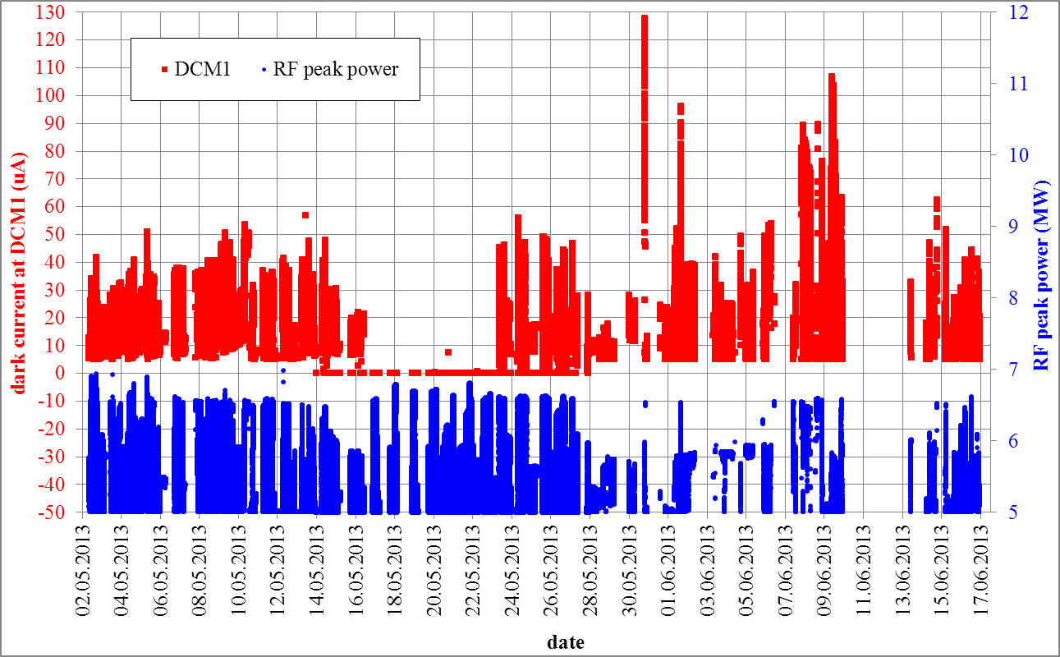
Figure 2.1.1: Dark current history during RF conditioning, Dark current monitor (DCM1) readouts for the RF peak power >5MW are plotted versus date.

References
[2.1] D. Malyutin et al, “First Results of a Longitudinal Phase Space Tomography at PITZ”, in proceedings of FEL 2013 conference.

