PITZ Shutdown Procedure

Switch off Gun (RF2):
Software shutdown procedure Step1:
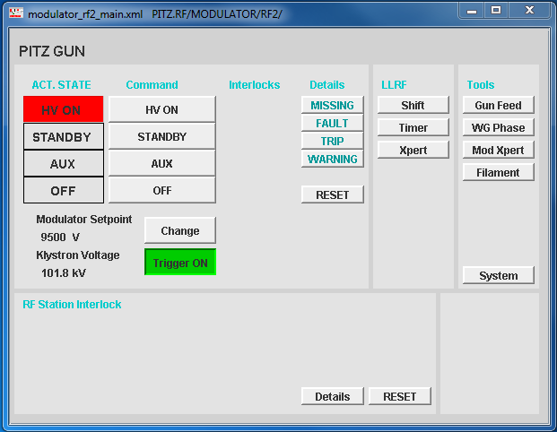
- Ensure that LLRF feed forward is off, if necessary switch off SMAC.
- Set Modulator Setpoint (voltage) to the minimal value (“Change” button 4000V) and wait until it reaches that voltage.
- Push “AUX” button.
- Push “Trigger” button (Trigger OFF).
- “Traffic light” has to move from HV ON to AUX.

Software shutdown procedure Step2:
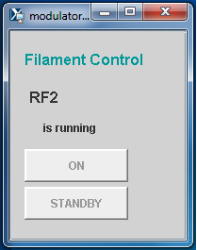
- Push “Filament” button.
- Push “STANDBY” button in Filament Control window.
In case of a longer shutdown please contact the experts from the RF-group.

Switch off Booster (RF1):
Software shutdown procedure Step1:
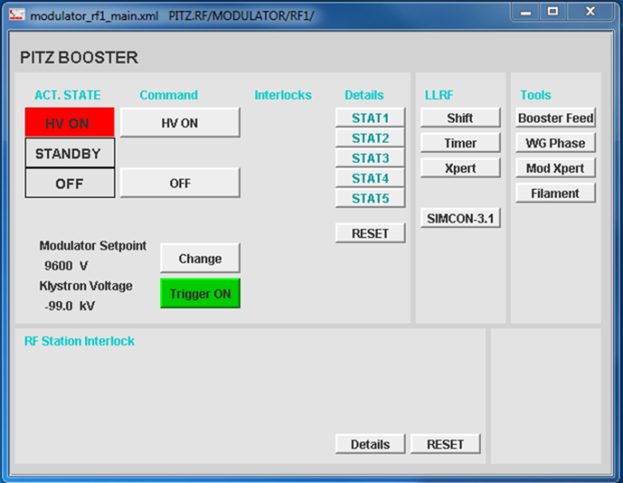

- Ensure that LLRF feed forward is off, if necessary switch off SMAC.
- Set Modulator Setpoint (voltage) to the minimal value (“Change” button 4000V) and wait until it reaches that voltage.
- Push “Trigger” button (Trigger OFF).
- Push Modulator “OFF” button.
- “Traffic light” has to move from HV ON to OFF.

Software shutdown procedure Step2:
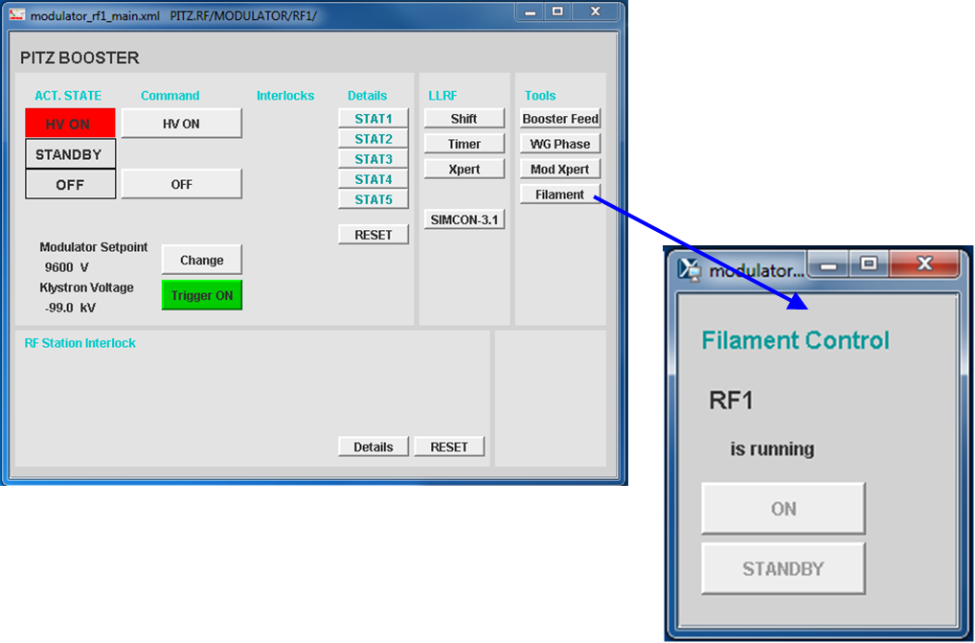
- Push “Filament” button.
- Push “STANDBY” button in Filament Control window.
In case of a longer shutdown please contact the experts from the RF-group.

Switch off TDS (RF5):
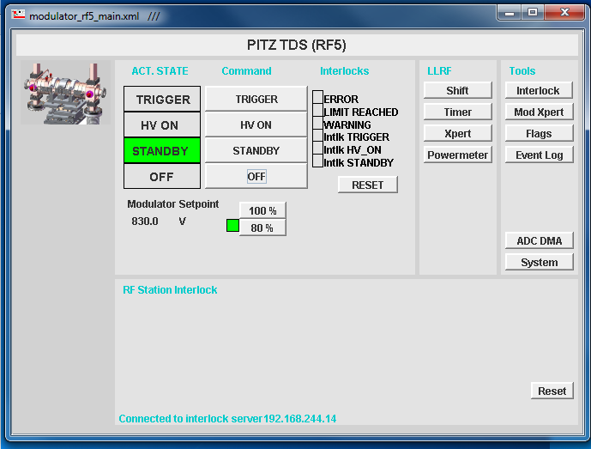

- Ensure that LLRF feed forward is off.
- Push “STANDBY” button.
- “Traffic light” has to move from TRIGGER to STANDBY.
Filament ramp-down process starts with activating “OFF” button and takes about 5 minutes.

Switch off all electronical devices in beam line:
- Go to: PITZ control/system.
- Push EVERY button in “open shutdown windows” from top to bottom and confirm the request

To be discussed (open PITZ control/system):
- New first button – “close all windows” (except PITZ control!)
  - reason: in that case the focus of the operator will always be on the right window
- Last button to be removed – “switch off modulator filament”
  - reason: part of RF2 and RF1 shutdown procedure

